

JDBC

By:
Mr.Satyendra Singh
Department of Computer Science & Engineering, ABESIT College of Engineering, Ghaziabad.

Mr. Satyendra Singh, CSE, ABESIT College of Engineering, Ghaziabad



JDBC Driver
. JDBC stands for Java Database Connectivity.
. JDBC is a Java API to connect and execute the query with the database.
. It is a part of JavaSE (Java Standard Edition).
. JDBC API uses JDBC drivers to connect with the database.

Java Database Connectivity
These steps are as follows:
- Register the Driver class: Class.forName("oracle.jdbc.driver.OracleDriver"); for Oracle: com.mysql.jdbc.Driver for SQL: Create
- connection:
Connection con=DriverManager.getConnection("jdbc:oracle:thin: @localhost:1521:xe", "system","password"); for Oracle

dbc:mysql://localhost:3306/sonoo
- Create statement:
Statement stmt=con.createStatement();
- Execute queries:
ResultSet rs=stmt.executeQuery("select * from emp"); while(rs.next()){
System.out.println(rs.getInt(1)+" "+rs.getString(2));
}
●
Close connection:
con.close();
for MySql

Java Database Connectivity with MySQL
import java.sql.*; class MysqlCon{
public static void main(String args[]){ try{
Class.forName("com.mysql.jdbc.Driver"); Connection con=DriverManager.getConnection( "jdbc:mysql://localhost:3306/sonoo","root","root");
//here sonoo is database name, root is username and password Statement stmt=con.createStatement();
ResultSet rs=stmt.executeQuery("select * from emp"); while(rs.next())
System.out.println(rs.getInt(1)+" "+rs.getString(2)+" "+rs.getString(3)); con.close();
}catch(Exception e){ System.out.println(e);}
}
}

import java.sql.*; class Test{

Connect Java Application with access with DSN
public static void main(String ar[]){ try{
String url="jdbc:odbc:mydsn"; Class.forName("sun.jdbc.odbc.JdbcOdbcDriver"); Connection c=DriverManager.getConnection(url); Statement st=c.createStatement();
ResultSet rs=st.executeQuery("select * from login");
while(rs.next()){
System.out.println(rs.getString(1)); } catch(Exception ee) { System.out.println(ee); }
} }

Types of JDBC Driver


Type0: JDBC-ODBC Bridge Driver, Type1:Native Driver, Type2:Network Protocol Driver Type3:Thin Driver

JDBC-ODBC bridge driver
- 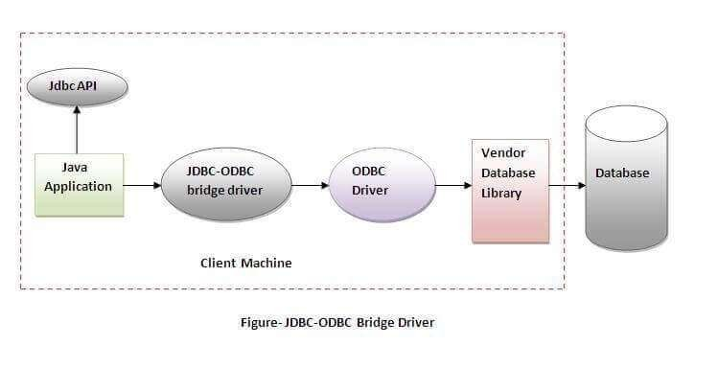The JDBC-ODBC bridge driver uses ODBC driver to connect to the database. The JDBC-ODBC bridge driver converts JDBC method calls into the ODBC function calls. This is now discouraged because of thin driver.

Note: In Java 8, the JDBC-ODBC Bridge has been removed.

JDBC-ODBC bridge driver

Advantages:
  - easy to use.
  - can be easily connected to any database.

Disadvantages:
  - Performance degraded because JDBC method call is converted into the ODBC function calls.
  - The ODBC driver needs to be installed on the client machine.
●
Type-0 driver isn’t written in java, that’s why it isn’t a portable driver.

Native-API driver

- The Native API driver uses the client-side libraries of the database. The driver converts JDBC method calls into native calls of the database API. It is not written entirely in java.

- 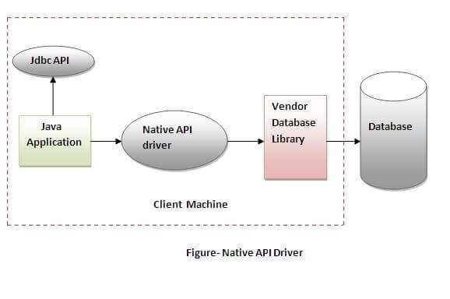This driver uses middlewareapplication server

Native-API driver
Advantage:
  - Performance upgraded than JDBC-ODBC bridge driver.
  - Type-1 drivers are fully written in Java, hence they are portable drivers.
  - No client side library is required because of application server that can perform many tasks like auditing, load balancing, logging etc.
Disadvantage:
  - The Native driver needs to be installed on the each client machine.
  - The Vendor client library needs to be installed on client machine.
●
Type-1 driver isn’t written in java, that’s why it isn’t a portable driver

Network Protocol driver

    - 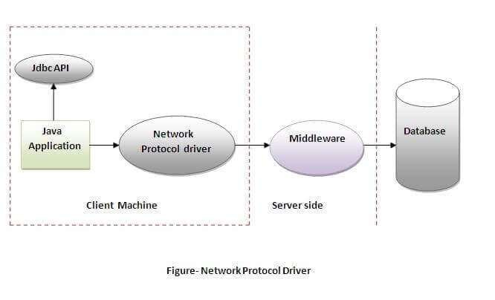The Network Protocol driver uses middleware (application server) that converts JDBC calls directly or indirectly into the vendor-specific database protocol. It is fully written in java.

Advantage:

- No client side library is required because of application server that can perform many tasks like auditing, load balancing, logging etc.

- Java application is accessing multiple types of databases at the same time, type 2 is the preferred driver.
Disadvantages:
- Network support is required on client machine.
- Requires database-specific coding to be done in the middle tier.
- Maintenance of Network Protocol driver becomes costly because it requires database-specific coding to be done in the middle tier.

Thin driver
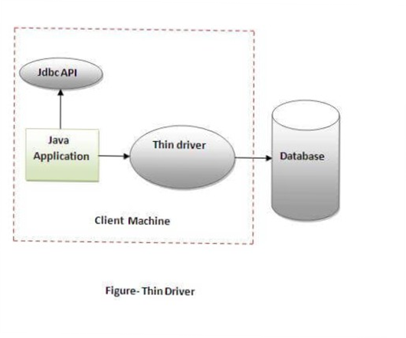
- The thin driver converts JDBC calls directly into the vendor-specific database protocol. That is why it is known as thin driver. It is fully written in Java language. Database such as Oracle, Sybase, or IBM

●

  - Better performance than all other drivers.
Advantage:

  - No software is required at client side or server side.
  - Does not require any native library and Middleware server, so no client-side or server-side installation.
  - It is fully written in Java language, hence they are portable drivers.
Disadvantage:
  - Drivers depend on the Database.

import java.sql.*; class OracleCon {
public static void main(String args[]) { try{ //step1 load the driver class
Class.forName("oracle.jdbc.driver.OracleDriver"); //step2 create the connection object
Connection
con=DriverManager.getConnection( "jdbc:oracle:thin:@localhost:1521:xe"," system","oracle"); //step3 create the statement object
Statement stmt=con.createStatement(); //step4 execute query ResultSet rs=stmt.executeQuery("select * from emp"); while(rs.next())
System.out.println(rs.getInt(1)+" "+rs.getString(2)+" "+rs.getString(3));
//step5 close the connection object
con.close(); } catch(Exception e) { System.out.println(e);}
} }



Questions ?

Mr. Satyendra Singh, CSE, ABESIT College of Engineering, Ghaziabad
16

